Much or many?

1. Look at the words. Circle all the countable nouns (many) in one colour and all the uncountable nouns (much) in another colour.

rice pencil water friend

cat love poster

sugar air money colour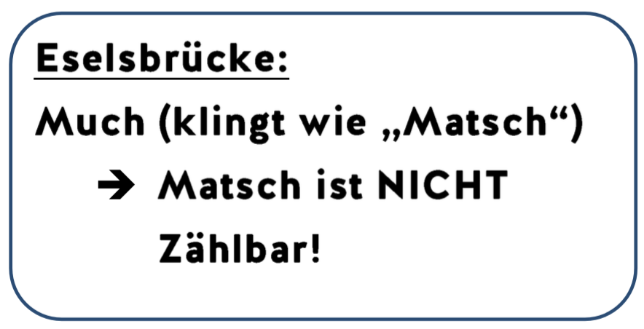

2) Fill in the gaps using “much“ or “many“

* 1. I have ________________ pencils.
  2. Ugh, there is so __________ sugar on my cake!
  3. There are so ____________ posters in my sister‘s bedroom.
  4. There isn‘t ____________ water left in my bottle.
  5. My brother doesn‘t have _________ friends.
  6. People can‘t live under water because there isn‘t ____________ air down there.
  7. My grandma has got ______________ flowers in her garden.
  8. I have not eaten ____________ today.
  9. I love my brother very _____________.
  10. There are not _____________ books in my shelf (=Regal).
  11. I don‘t have _____________friends.
  12. You don‘t need _____________ mobile phones. You just need one.
  13. We eat _____________ vegetables and fruits.
  14. Susan‘s family doesn‘t have _____________ money.